**IPSec VPN EX实验报告**

**一、拓扑图**

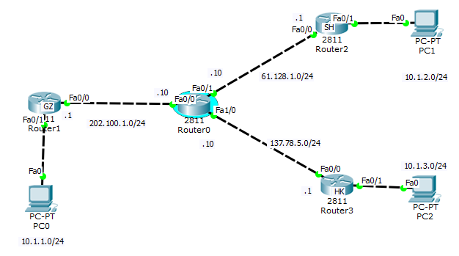

**二、配置信息**

**GZ与SH间PC安全通信：**

Router2:

crypto isakmp policy 10

encr 3des

hash md5

authentication pre-share

group 2

crypto isakmp key vpn address 202.100.1.1

crypto ipsec transform-set myset esp-3des esp-sha-hmac

access-list 100 permit icmp host 10.1.2.1 host 10.1.1.1 设置感兴趣流

crypto map vpnex 10 ipsec-isakmp

set peer 202.100.1.1

set transform-set myset

match address 100

ip route 202.100.1.0 255.255.255.0 61.128.1.10

ip route 10.1.1.0 255.255.255.0 61.128.1.10

Router1:

crypto isakmp policy 10

encr 3des

hash md5

authentication pre-share

group 2

crypto isakmp key vpn address 61.128.1.1

crypto ipsec transform-set myset esp-3des esp-sha-hmac

access-list 100 permit icmp host 10.1.1.1 host 10.1.2.1

crypto map vpnex 10 ipsec-isakmp

set peer 61.128.1.1

set transform-set myset

match address 100

ip route 61.128.1.0 255.255.255.0 202.100.1.10

ip route 10.1.2.0 255.255.255.0 202.100.1.10

**GZ与HK间PC安全通信：**

Router3:

crypto isakmp policy 100

encr 3des

hash md5

authentication pre-share

group 2

crypto isakmp key vpn address 202.100.1.1

crypto ipsec transform-set myset esp-3des esp-sha-hmac

access-list 100 permit icmp host 10.1.3.1 host 10.1.1.1

crypto map vpnl 10 ipsec-isakmp

set peer 202.100.1.1

set transform-set myset

match address 100

ip route 202.100.1.0 255.255.255.0 137.78.5.10

ip route 10.1.1.0 255.255.255.0 137.78.5.10

Router1:

crypto isakmp policy 100

encr 3des

hash md5

authentication pre-share

group 2

crypto isakmp key vpn address 137.78.5.1

crypto ipsec transform-set myset esp-3des esp-sha-hmac

access-list 100 permit icmp host 10.1.1.1 host 10.1.3.1

crypto map vpnl 10 ipsec-isakmp

set peer 137.78.5.1

set transform-set myset

match address 100

ip route 137.78.5.0 255.255.255.0 202.100.1.10

ip route 10.1.3.0 255.255.255.0 202.100.1.10

**三、详细验证过程**

**查看：**



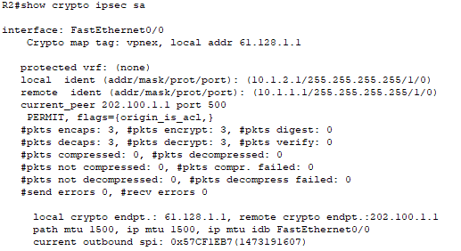



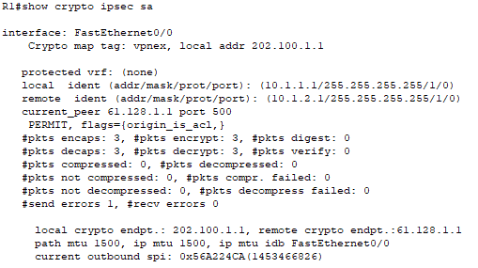

**Ping通测试：**

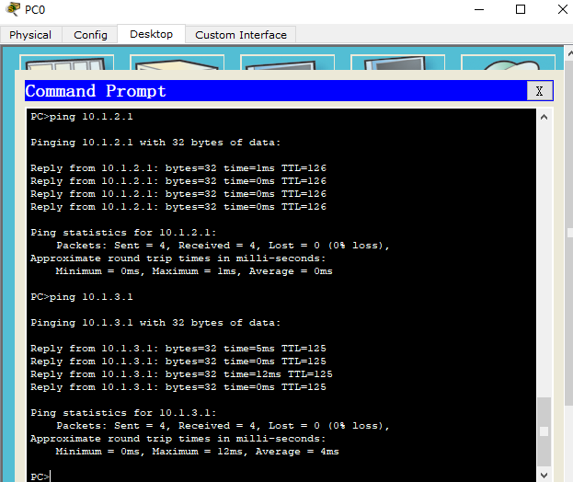

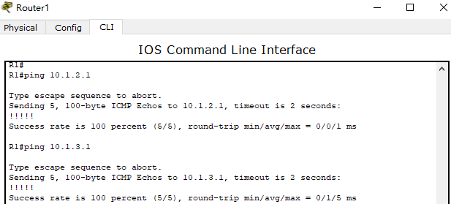

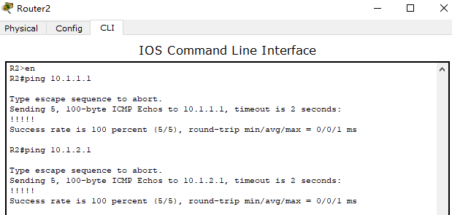

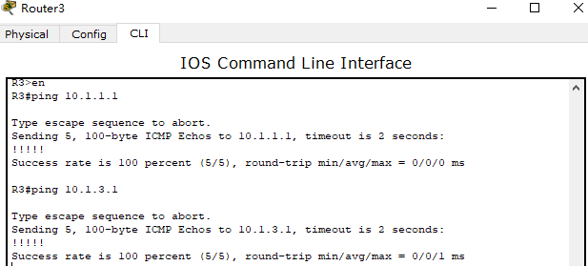

**四、实验过程注意事项**

Router0：

ip route 10.1.1.0 255.255.255.0 202.100.1.1

ip route 10.1.2.0 255.255.255.0 61.128.1.1

ip route 10.1.3.0 255.255.255.0 137.78.5.1